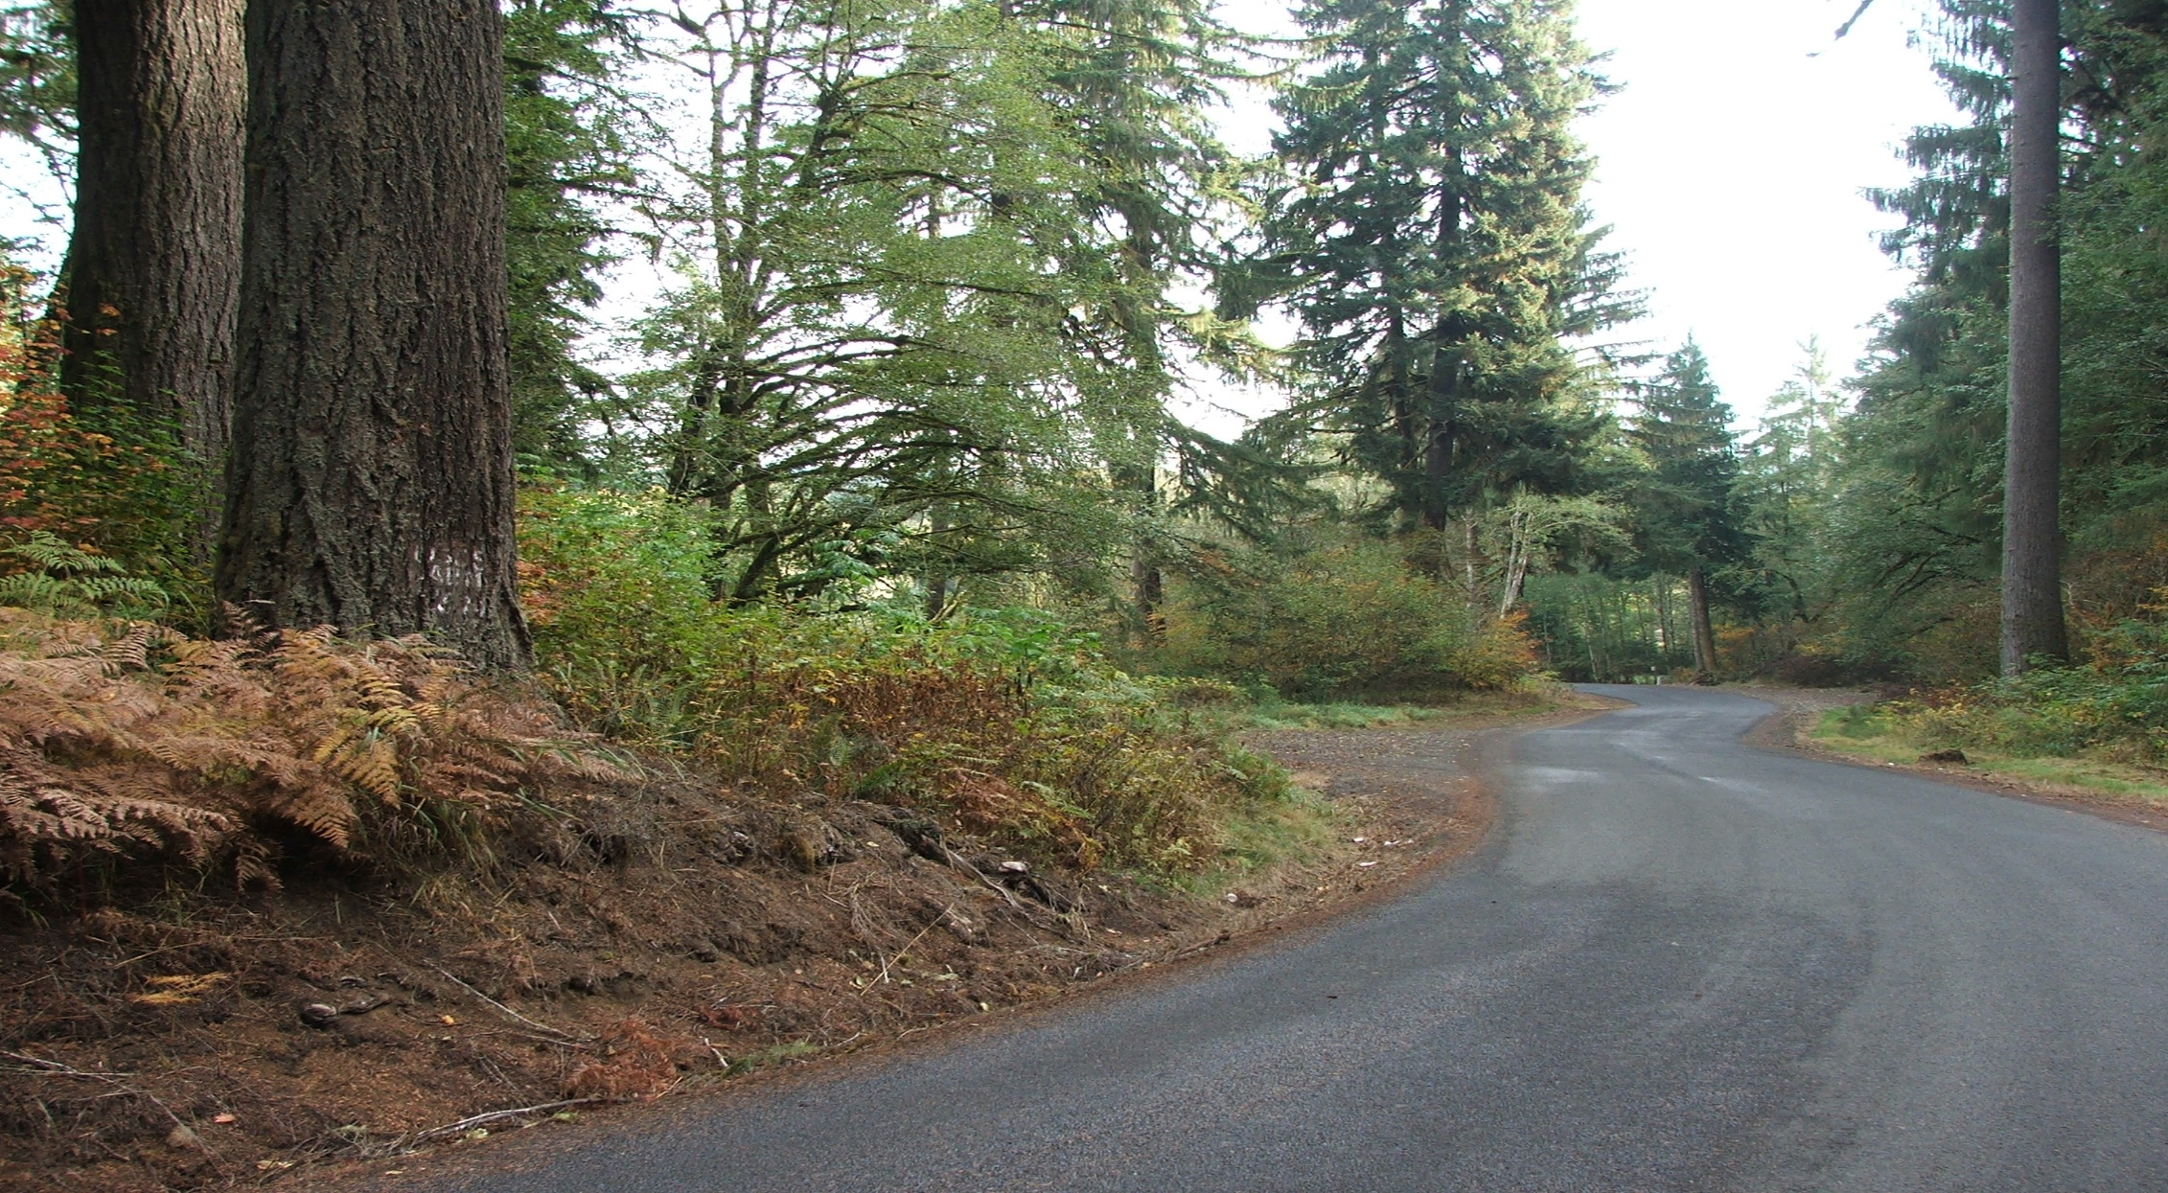
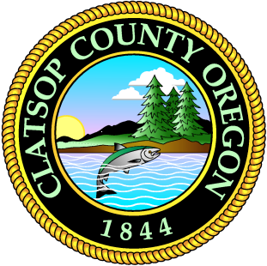
2040
SEASIDE RURAL COMMUNITY PLAN
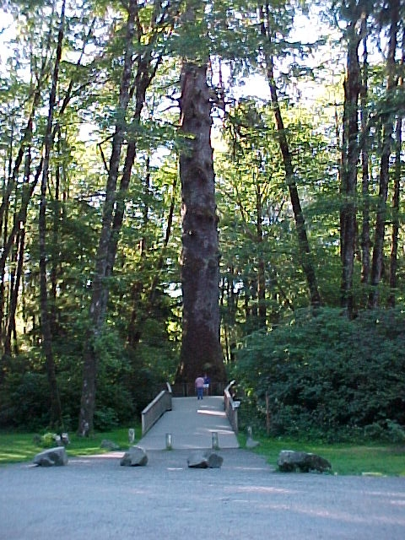
ADOPTED JULY 23, 2022
BOARD OF CLATSOP COUNTY COMMISSIONERS
- Mark Kujala, Chair (District 1)
- Lianne Thompson, Vice-Chair (District 5)
- John Toyooka (District 2)
- Pamela Wev (District 3)
- Courtney Bangs (District 4)
SEASIDE RURAL CITIZEN ADVISORY COMMITTEE
- Pam Birmingham, Chair
- Susana Gladwin, Vice-Chair
- Don Abing
- Jody Abing
- Connie Moore
- Herb Olstedt
CLATSOP COUNTY PLANNING COMMISSION
- Nadia Gardner, Chair
- John Orr, Vice-Chair
- Christopher Farrar
- Cary Johnson
- Lam Quang
- Robert Stricklin (former member)
STAFF
- Don Bohn, County Manager
- Monica Steele, Assistant County Manager
- Julia Decker, Planning Manager
- Ian Sisson, Senior Planner
- Jason Pollack, Planner
- Victoria Sage, Planner
- Clancie Adams, Permit Technician
- Gail Henrikson, Community Development Director

Table of Contents
INTRODUCTION 4
LANDSCAPE UNITS 4
Introduction 5
Alluvial Lowlands 5
Alluvial Terraces 5
Marine Terrace 5
Sedimentary Lowlands 5
Sedimentary Uplands 5
Basaltic Lowlands and Highlands 5
Estuary and Coastal Shorelands 5
Ecola Creek Estuary 5
Tillamook Head 5
NATURAL HAZARDS 4
Stream Flooding 5
Streambank Erosion 5
Mass Movement 5
High Groundwater 5
Wildfire 5
NATURAL RESOURCES 4
Mineral Resources 5
Water Resources 5
Forestry and Agriculture 5
CULTURAL 4
Housing 5
Recreation 5
Open Space, Historic, Scenic and Natural Areas 5
Transportation 5
Public Facilities and Services 5
Water Districts 5
Groundwater Wells 5
Schools 5
Fire Protection 5
Septic Systems 5
Power Generation 5
COMMUNITY DEVELOPMENT 5
Setting 5
Assumptions 5
Development 5
Rural Lands and Rural Agricultural Lands 5
Forest Lands and Conservation Other Resources 5
Natural 5
GOALS, OBJECTIVES AND POLICIES 5
Index to Maps and Figures

MAP 1: Landscape Units of the Seaside Rural Planning Area 2
MAP 2: Geologic Hazard Areas 2
MAP 3: Special Flood Hazard Areas 2
MAP 4: Open Space, Parks and Recreation 2
MAP 5: Special Districts 2

FIGURE 1: General Landscape Units 2
FIGURE 2: North Coast Basin Map 2

TABLE 1: Surface Mining Operations 2
TABLE 2: Fish and Wildlife 2
TABLE 3: Seaside Rural Planning Area – School Systems 2

INTRODUCTION
The original Seaside Rural Community Plan was adopted on July 23, 1980 (Ordinance 80-07). This plan, along with the community plans for each of the other five planning areas in Clatsop County are broken down into landscape units. Goals, objectives, policies and/or recommendations are provided for each of the landscape units. Additional sections in each community plan also include specific policies for the planning area related to the 18 statewide planning goals. Since originally adopted, the Seaside Rural Community Plan has been amended twice:
Seaside Rural Community Plan
- 81-07: Goal 16 exception to allow a wetlands/marsh wastewater treatment system in and adjacent to the Ecola Creek Estuary
- Ordinance 83-17: Amendments to address comments from the Department of Land Conservation and Development (DLCD)
LANDSCAPE UNITS
INTRODUCTION
The basic idea of the landscape unit is that it reflects a set of characteristics which, taken together, constitute a natural process. The soils, hydrology, wildlife, vegetation, and land forms are interrelated as a functional unit. The landscape units provide a framework for development that is, in part, based on the land's capability and capacity. Each piece of land is in a landscape unit. The landscape units which occur in the Seaside Rural planning area (Figure 1) are Marine Terrace, Alluvial Lowlands and Uplands, Basaltic Lowlands and Highlands, and Headlands and Points. Map 1 shows their locations in the Seaside Rural planning area. These designations and locations, which were identified in the late 1970s, should be reviewed by DOGAMI to verify the locations.

FIGURE 1: GENERAL LANDSCAPE UNITS
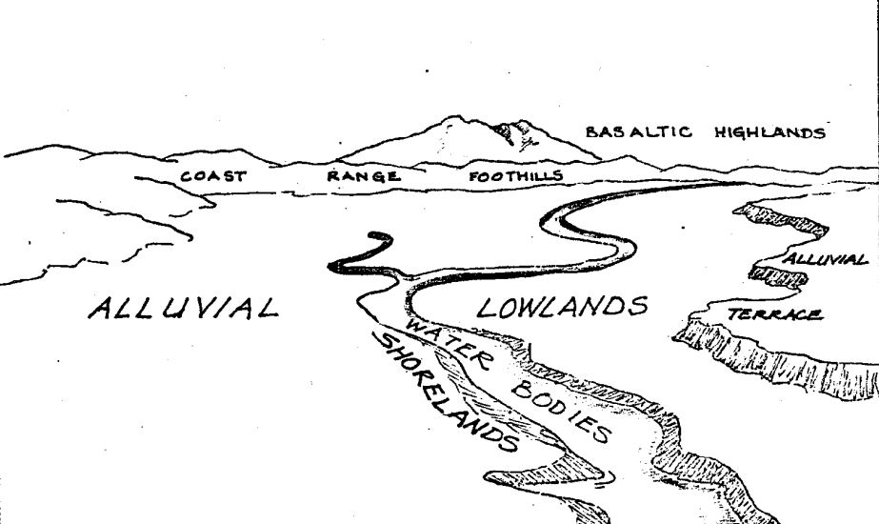

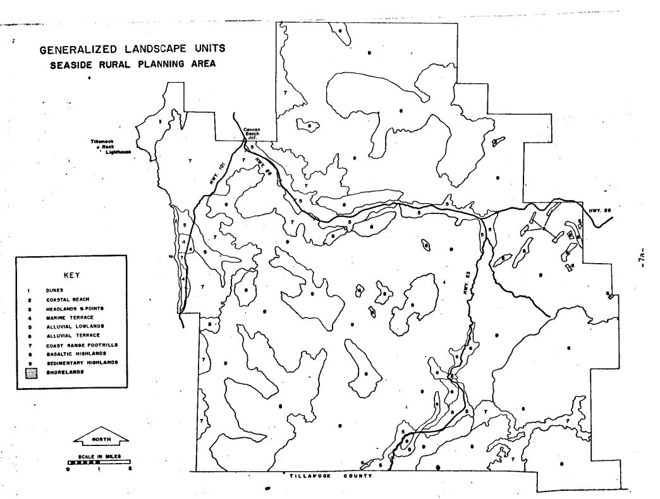
MAP 1: LANDSCAPE UNITS OF THE SEASIDE RURAL PLANNING AREA
ALLUVIAL LOWLANDS
Alluvial lowlands are plains occupying valley floors which result from the deposition of clay, silt, sand, and gravel by water.
There are two areas of alluvial lowlands within the Seaside Rural area; the Necanicum River which empties into the estuary within the Seaside city limits, and the North Fork of the Nehalem River that drains the eastern part of the planning area.
The Necanicum River has carved out an alluvial valley for about 16 miles through sedimentary rocks in the northern part of the Seaside Rural area. The valley is underlain by gravel deposits. The alluvial gravels consist of poorly sorted sand, silt, and clay with some beds of basaltic pebbles and cobbles.
The largest alluvial lowland is the valley created by the North Fork of the Nehalem River. This valley extends about 6 miles north from the Tillamook County line. The North Fork drains much of the southwest part of the County ultimately into Nehalem Bay, just after it joins the main stream of the Nehalem River. This area consists primarily of silty clay, clay, and silty clay mixed with gravel. The slope of the lowlands is gentle, between 8 and 9%.
The major geological hazard in the alluvial lowlands is stream flooding. Further information on this subject is contained in the section on Critical Hazards.
ALLUVIAL TERRACE
Alluvial terraces are relatively flat or gently sloping surfaces marking former valley floors. Stream downcutting has caused the terraces to be higher than the present valley floor.
Alluvial terraces are found along the northern portions of the Necanicum River and generally east of the Nehalem along the North Fork. Terrace deposits consist mostly of clay and gravel.
This landscape unit is scarce in the planning area. Most of the property is productive timber land and presently in forest uses.
MARINE TERRACES
Marine terraces are relatively flat surfaces eroded by wave action. They are composed of relatively flat-lying or gently ocean-sloping compacted but uncemented sediments, rarely above 50 feet in elevation.
At Cannon Beach, the marine terrace deposits extend inland for about 3/4 mile into the planning area. Most of the development that has occurred in the town is on the marine terrace formation. The land slopes from mountain to sea, affording many homes a view. This area is contained within the Cannon Beach Urban Growth Boundary.
SEDIMENTARY LOWLANDS
Sedimentary lowlands are low subsidiary hills on the edges of the uplands. In the Seaside Rural area, they occur in the western portion of the planning area in and around Cannon Beach. They range in elevation from 50 to 500 feet, and are generally composed of sedimentary rock of Oligocene to Miocene age. They tend to have rounded ridge tops with slopes varying from 10 to 60%.
The sedimentary lowlands lie in an area of landslide topography. This is due to a combination of slope and bedrock material. When moisture comes in contact with the siltstone or claystone formations, fringe between the soil and rock is reduced, and the force of gravity provides the impetus to push the overburden down a slope.
Most of the area containing this landscape unit is in timber production.
SEDIMENTARY UPLANDS
Sedimentary uplands consist of Coast Range Mountains over 500 feet, underlain chiefly by sedimentary rocks. Slopes may vary from 10 to 60%.
Sedimentary uplands compose the most common landscape unit in the planning area, interrupted in places by massive basalt outcrops.
The soils of the sedimentary uplands are the same, for the most part, as the sedimentary lowlands. The uplands, however, consist of mostly steep to very steep slopes which makes for rapid runoff and high erosion hazard.
Most of these lands are utilized for timber production by the large timber companies. However, there are some other land holdings containing this landscape unit in the Hamlet area, but the slopes are not above 20% reducing the presence of hazards.
BASALTIC LOWLANDS AND HIGHLANDS
Basaltic lands are underlain by igneous material. Most of the highlands are over 1,200 feet in elevation though outcrops of basalt are also exposed at lower elevations. Slopes are frequently over 40%. They are scattered throughout the planning area, but the most prominent outcrops encompass Angora, Onion, and Twin Peaks and Sugarloaf Mountain.
The slope of the basaltic formations ranges from 30% to 60%, with several near-vertical cliffs. Due to the density and crystalline structure of these formations, the basaltic lands do not contain the geologic hazards of other units. Basaltic rocks are more resistant to erosion than the sedimentary formations and, therefore, less liable to experience landslides. Rockfall can occur, however. Their isolation, slope and elevation make them generally unsuitable for most human activity. Because of their composition, they could constitute important mineral resources in terms of quarry rock for construction purposes. These areas are an important visual component of the County, providing the rugged, wild counterpart to the rest of the landscape that makes the area so unique.
ESTUARY AND COASTAL SHORELANDS
Ecola Creek Estuary
Ecola Creek is a well-mixed tidal creek having very low marine biological and moderate terrestrial biological value. Tidal influence extends to just above the U.S. 101 bridge a total distance of one-half mile.
Ecola Creek has no definable eel grass beds or tidelands. The adjacent land as well as the land edge character is moderately diverse, and is comprised of a bulrush and sedge wetland above the U.S. Highway 101 bridge and a small wetland area located within the Cannon Beach city limits.
Ecola Creek has sediments of mixed sand, gravel, and mud. These sediment types combined with low salinities limit Elk Creek to small anadromous fish runs of coho and steelhead trout. But for its size, Elk Creek sustains a fairly large stable run of native searun cutthroat trout.
The City of Cannon Beach has utilized approximately 68 acres of the marsh to the west of Highway 101 for an artificial marsh sewage treatment system.
Tillamook Head
The most northerly and largest coastal headland in Clatsop County is Tillamook Head, which has been described as "a complex of bold headlands, points of land, intervening coves, and shallow indentations." West Point, Bird Point, and Indian Point are part of this promontory.
Tillamook Head is composed of middle to late Miocene basaltic intrusive rock which includes thick sills, dikes, ring dikes, and pod-life bodies. The seaward side of the headland consists of basaltic flows and sills. Many active landslides have been mapped in the Tillamook Head area, and have caused and continue to cause much destruction to Ecola State Park.
Much of the area on top of Tillamook Head that is under State control is still in old growth forest, and as such constitutes a rare natural area in Clatsop County. The Oregon Department of Parks and Recreation has previously acquired additional acreage at Tillamook Head to provide a buffer to protect the park forests against wind throw which could occur when the adjacent forests are logged. The expansion of the park also protected the historic and primitive character of the headland trail, providing viewpoints of the farthest exploration area of the Lewis and Clark expedition of 1806.
NATURAL HAZARDS
STREAM FLOODING
Because housing sites along rivers are picturesque, they are increasing at a rapid rate. Many of these scenic locations are hazardous floodplains - the area intended by nature to accommodate the discharge and overflow of its waterways.
Major flood areas of the Seaside Rural area are on the Necanicum River and the North Fork of the Nehalem River between the southern County border and the hatchery. These streams overflow their banks at certain periods of the year, when heavy rainfalls, melting snow, high tides, strong winds, or restricted channels occur.
Clatsop County has participated in the National Flood Insurance Program since 1974. A floodplain ordinance was adopted in 1978 and continues to be in effect. In 2018, the County was required to update the floodplain ordinance when Flood Insurance Rate Maps (FIRMs) were updated for properties along the Pacific Ocean coast. On October 1, 2021, FEMA implemented its Risk 2.0 Insurance Mapping Program. This program is intended to revise flood insurance rates based not only upon a structure’s location to the Base Flood Elevation (BFE), but also to reflect the rebuild cost of the structures themselves. The revisions stem from a decades-long de facto subsidization of larger, higher-cost housing in flood-prone areas by smaller, lower-cost dwellings. The program will adjust flood insurance rates over a period of several years until property owners are paying the full amount of the costs to insure their buildings. This will result in a premium decrease for some property owners within the county, but may result in higher premiums for other property owners.
General policies regarding flood hazards, stream flooding and other hazards are contained in the County-wide Natural Hazards Element of the Comprehensive Plan.
General policies relating to stream flooding are addressed in the County-wide Natural Hazards County-wide Element.

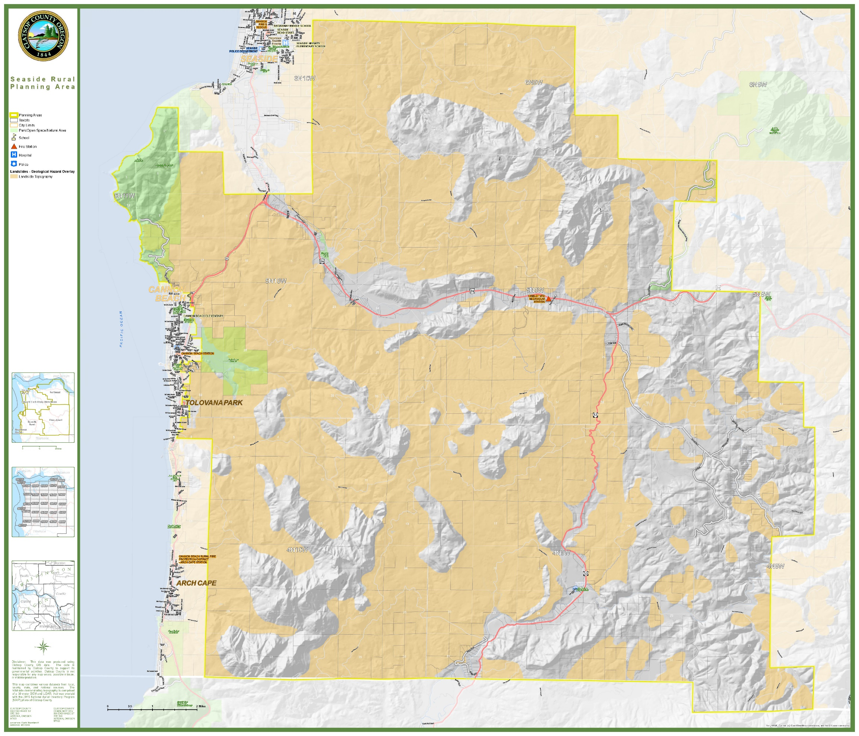
MAP 2: GEOLOGIC HAZARD AREAS

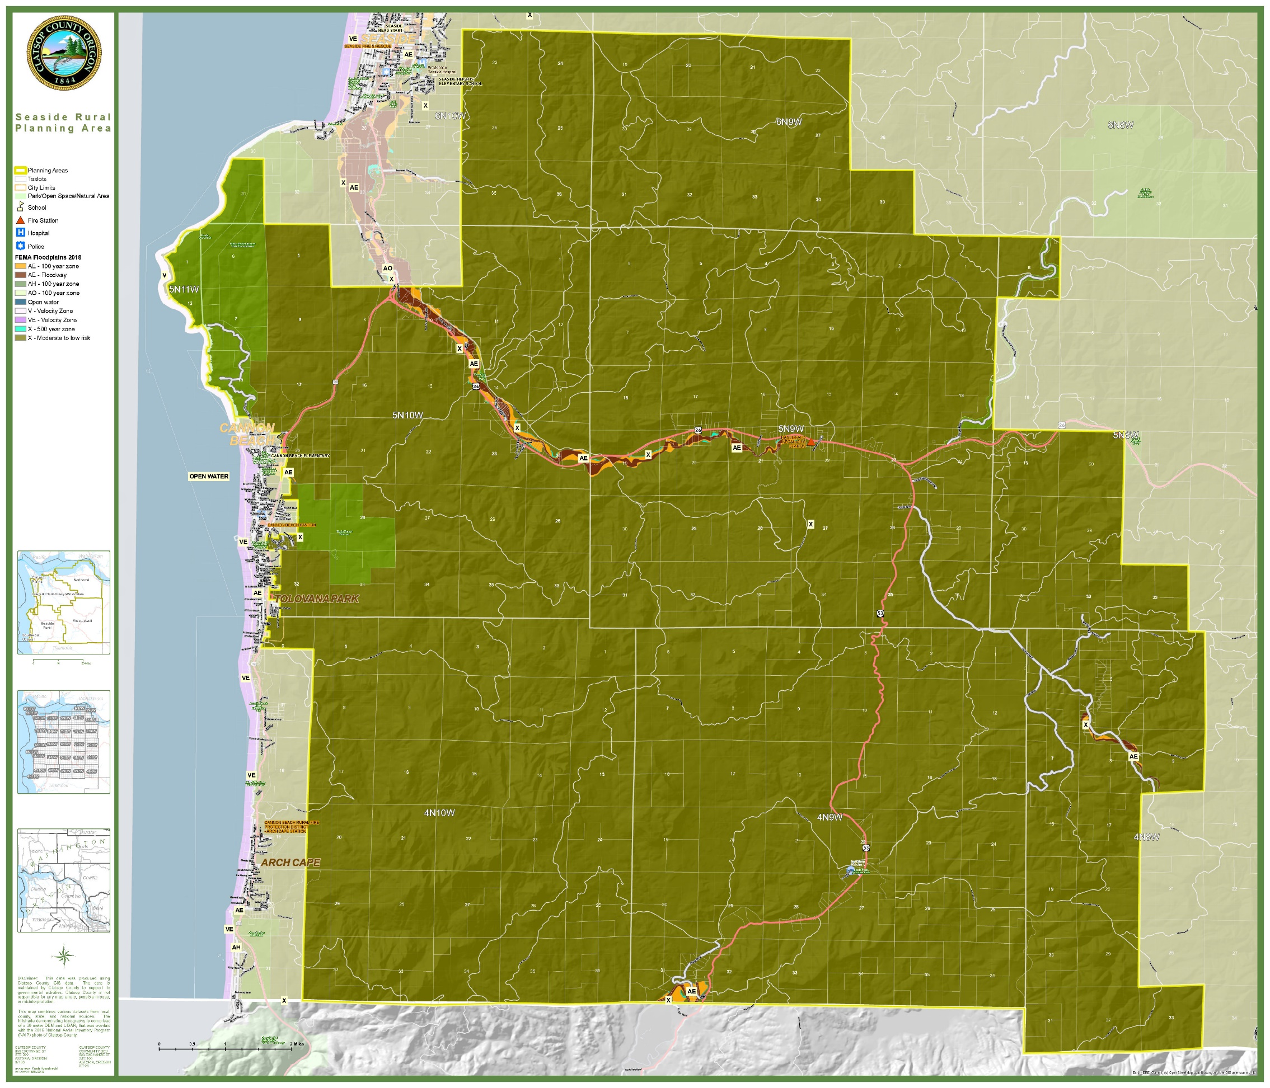
MAP 3: SPECIAL FLOOD HAZARD AREAS

Streambank Erosion
The outer banks along channel curves are the most susceptible to streambank erosion because it is there that the momentum of the water carries it against the bank with the most force. Actual erosion rates are not known but are quite severe in spots along the Necanicum.
Allowing trees and other vegetation to remain on the banks, (i.e., providing a buffer) is essential to the health of the stream generally. The riparian vegetation stabilizes the banks and provides shade and cooling.
Prescribing a setback for improvements is another common method of safeguarding against potential damage but is difficult to prescribe due to the varying degrees of erosion that occur. In areas of severe streambank erosion, it sometimes becomes necessary for a property owner to install riprap or other protection when a home is in danger. Sometimes this type of action can cause potential harm to neighboring properties.
Mass Movement
Much of the land in the Seaside Rural area consists of old landslide topography which are land areas of rolling ground in which landslides could have occurred up to several thousand years ago. Due to the geologic conditions of the region these areas are still subject to movement. Such landslides are occurring in Ecola Park and above Cannon Beach. Many smaller unmapped landslides are present and can move when disturbed. Human actions, such as construction of buildings or roads, have also precipitated landslides.
Landslides, soil creep, slumping, or rockfall are all elements of mass movement. According to the Natural Resources Conservation Service (NRCS), certain soils consistently have mass movement potential at slopes above 20%.
General policies relating to mass movement are addressed in the Countywide Natural Hazards Element.
High Groundwater
In the alluvial lowlands near streams, high groundwater is near the surface much of the year.
High groundwater can create hydrostatic pressure problems in that water pressure can fracture the floors and walls of basements if allowed to build up. Health hazards can also be created where septic tanks cannot drain properly. Department of Environmental Quality (DEQ) rules prohibit the issuance of septic tank permits when the permanent groundwater level is within 5-1/2 feet of the ground surface.
In the Seaside Rural area, major areas of high groundwater occur along the Necanicum River and North Fork of the Nehalem just north of the Tillamook County line. There are also minor areas between the mouth of the Klootchie Creek and the Necanicum Fish Hatchery.
General policies relating to high groundwater and associated compressible soils are also addressed in the Countywide Natural Hazards Element.
WILDFIRE
Fire is an essential part of Oregon’s ecosystem, but it is also a serious threat to life and property particularly in the state’s growing rural communities. Wildfires are fires occurring in areas having large areas of flammable vegetation that require a suppression response. Areas of wildfire risk exist throughout the state with areas in central, southwest and northeast Oregon having the highest risk.
The Future Climate Projections Clatsop County report issued by the Oregon Climate Change Research Institute in February 2020, states that over the last several decades, warmer and drier conditions during the summer months have contributed to an increase in fuel aridity and enabled more frequent large fires, an increase in the total area burned, and a longer fire season across the western United States, particularly in forested ecosystems. In Clatsop County, the frequency of very high fire danger days per years is projected to increase on average by 10 days, with a range of -3 to +28 days by 2050. Given the predominance of forested land in the Seaside Rural Planning Area, increased wildfire frequency poses a significant risk.
TSUNAMI
Tsunamis have historically been rare in Oregon. Since 1812, Oregon has experienced about a dozen tsunamis with wave heights greater than 3 feet; some of these were destructive. A small area to the east of the City limits of Cannon Beach is located within the tsunami regulatory line. DOGAMI provides maps detailing the inundation zones. Tsunami impacts in this area will likely destroy roads and structures and isolate this area for days or weeks. An evacuation route should be located within the Seaside Rural Planning Area.
EARTHQUAKE / CASCADIA SUBDUCTION ZONE EVENT
A Cascadia Subduction Zone (CSZ) event is the most likely event to severely impact the Seaside Rural Planning Area. In the event of a CSZ event, this area will be isolated as roads and transportation systems will likely be severely damaged or destroyed. CERT volunteer training should be encouraged and cache areas and assembly points should be identified and developed. The County should promote education to ensure that residents and households are prepared to be self-sufficient for a minimum of two weeks in the event of a CSZ occurance.

NATURAL RESOURCES
The Seaside Rural area has an abundance of natural resources. Forests cover much of the area and numerous streams flow towards the ocean. There are many potential sources of rock in the area.
Natural Resources
The two most common mineral resources in Clatsop County are sand and gravel, and crushed rock deposits. Sand and gravel are found in stream channels and bars, in the alluvial deposits of the stream valleys and in certain rocky beaches. Crushed rock is rare and valuable and is basaltic in origin. It has also been noted during the update of this plan that the economic benefits must also be tempered with measures to protect residents from negative impacts from blasting associated with mining activities. Such measures might include limitations on hours when blasting activities could be conducted. Information from DOGAMI indicates the following active surface mining operations in the Seaside Rural Planning Area:
TABLE 1: SURFACE MINING OPERATIONS
SITE NAME | PERMITTEE | LOCATION
Volmer Creek | Big River Excavating | https://www.google.com/maps/@?api=1&map_action=map&center=45.913868,-123.894119&zoom=16&basemap=satellite
Square Creek Pit | Bayview Asphalt Inc. | https://www.google.com/maps/@?api=1&map_action=map&center=45.939774,-123.934647&zoom=16&basemap=satellite

The Seaside Rural area has many other areas of igneous rock and intrusive basalt outcrops. These areas of basalt rock should be examined for possible sites of future rock quarries to help the County meet its growing demands. Most of the areas are presently in forest management.
Policies and standards relating to mineral resources are handled in the Open Spaces, Scenic and Historic Areas, and Natural Resources Background Report and Countywide Element.
Water Resources
Per information from the Oregon Department of Environmental Quality (DEQ) the Seaside Rural Planning Area is located within the North Coast Basin, which extends from the Columbia River to the southern Tillamook County line (Figure 2). The basin consists of eight watersheds. Six watersheds drain to the Pacific Ocean:
- Necanicum
- Nehalem
- Tillamook Bay
- Nestucca
- Netarts/Sand Lake
- Neskowin
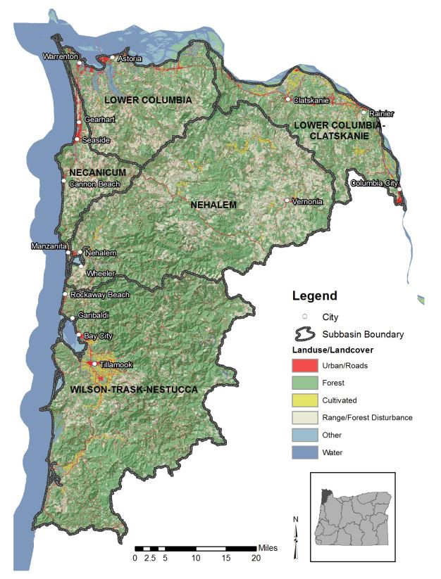
Two of the watersheds drain to the Columbia River:
Source: Oregon Department of Environmental Quality
FIGURE 2: NORTH COAST BASIN
- Lower Columbia
- Lower Columbia-Clatskanie
The Seaside Rural area is very humid (80-120 inches of rain per year) resulting in contains many streams transporting water to the ocean. The major rivers in the area are the Necanicum River, which flows northwest through the northern part of the study area, and the North Fork of the Nehalem, which flows southwest and drains the southeast part of the planning area. Elk Creek drains most of the area immediately behind Cannon Beach. Circle and Klootchie Creeks are major tributaries of the Necanicum River.
Grassy Lake and Soapstone Lake are the only lakes in the area. Grassy Lake is a small, successional lake rapidly turning to marshy bog in the uplands between Onion Peak and Sugarloaf Mountain. Soapstone Lake is a 10-acre lake at 550 feet elevation, and is located east of Highway 53. The Seaside reservoir, located two miles south of the City, is a two-acre body of water used to supply water to the City of Seaside and selective residents of the Seaside Rural area.
The Cannon Beach watershed is located along the west fork of Elk Creek about 3/4 of a mile upstream from the confluence of the forks. The City has taken an active role in managing its watershed, purchasing nearly a thousand acres and developing the Ecola Creek Forest Reserve (ECFR) Plan. Located approximately one mile from the Pacific Ocean, the ECFR covers approximately 1,040 acres and is owned by the City of Cannon Beach. With a maximum elevation of 3,075 feet, the headwaters of the watershed are steep and mountainous. Over 95% of the lands in the watershed are managed for industrial timber production, with private land ownership over the last few decades passing from Crown Zellerbach to Willamette Industries, to the Weyerhaeuser Company, and to the Campbell Group, a timber investment firm. In 2005, Weyerhaeuser sold a portion of the upper watershed to Stimson Lumber. Harvest activity continues on lands adjoining the Reserve. The watershed totals 15 acres of old growth and 45 acres of second growth timber which the City owns. Located within the watershed are some rather large old growth red cedar. The watershed provides some water quality protection of the City water supply which comes from three springs. But the City is concerned that logging and spraying of the commercial timber land which surrounds the watershed could seriously affect water quality.
The streams in this area of the County are an invaluable resource. These streams provide water for the residents of the area, as well as providing habitat for both fish and wildlife. The streams in the area fluctuate considerably between January and August. During the winter months when the streams are at their peak, there is plenty of water in the stream channels.
Forestry and Agriculture
In the Seaside Rural area, the majority of the forest land is in corporate and public ownership and covers over 90% of the total land area. In the past the forests of the area were mostly composed of old growth Douglas Fir, but logging and forest fires have altered this considerably. These lands are intensively managed for timber production, a primary industry of the County. Recognizing this fact, the major forest lands are preserved in the Plan under a Forest Lands designation.
Some agricultural activity in the Seaside Rural area occurs along the Necanicum River Valley, the North Fork Nehalem River Valley, and two areas along the Little North Fork. While these areas were previously thought to have low potential for agriculture because of past development that resulted in small parcel sizes, farming does occur in the area on a small- to moderate-scale. These activities are considered compatible with rural residential living.
General policies concerning forestry and agriculture can be found in Goals 3 and 4 of the Countywide comprehensive plan.
CULTURAL
Housing
The Seaside Rural area is very sparsely settled, containing only 236 310 existing residences; the current distribution being 183 conventional single family residences, 51 mobile homes, and 2 duplexes. Most of the homes in the area are between 20-50 years of age and may require major repairs in the future. However, over 18% of the homes are newer. Approximately 47% of the dwellings were constructed prior to 1980. Approximately 60% of the dwellings were constructed prior to 1990.
Between 2005 and November 24, 2021, 39 permits were issued for new single-family and two-family dwellings in the Seaside Rural Planning Area. Building construction in the Seaside Rural area has been fairly steady in the past (between 10-11 new dwellings/year) and increasing. In 1977 and 1978 the area received almost an equal amount of mobile homes to conventional dwellings. Thirty-six percent of the new construction was for out-of-town owners.
The current population in the area is 387 with an average household size of 2.5 persons per dwelling. The County population study forecasts permanent population will increase slowly with an additional 138 persons expected by the year 2000.
The County Housing Report forecasts the total housing units needed by the year 2000 to be 136, including 55 permanent residences and 81 seasonal units.
Recreation
Existing recreational facilities in the Seaside Rural area consist of the following:
State Parks
Within this planning area, there two State parks (Ecola and Elmer Feldenheimer State Natural Area).
Ecola State Park has picnic facilities as well as a hiking trail to the top of Tillamook Head or across the head to Ecola Point and Indian Beach. The park stretches along nine miles of coastline and offers outstanding sightseeing and recreational opportunities, including cliff side viewpoints of secluded coves, forested promontories and a long-abandoned lighthouse. The park’s network of trials includes an eight-mile segment of the Oregon Coast Trail, and a 2 ½ mile historical interpretive route called the Clatsop Loop Trial.
Elmer Feldenheimer is a Forest Preserve to the east of Ecola and was created to protect forested areas in Ecola State Park.
Oregon Scenic Waterways
In 2019, a 17.5-mile portion of the Nehalem River between Henry Rierson Spruce Run Campground and the confluence with Cook Creek near cougar Valley State Park, was designated as an Oregon Scenic Waterway. Oregon Parks and Recreation Department is currently working with a Rules Advisory Committee to finalize river-specific rules for the designated stretch of river.
County Parks
North Fork Nehalem Park - This three-acre park is located on Highway 53. No facilities are provided, although the park has fishing access, open space and water access.

Klootchie Creek Park – This park is located off U.S. Highway 26, about 2 ½ miles southeast of the U.S. 101 junction, five miles from Seaside and Cannon Beach. The park is comprised of 25 acres and has restroom facilities, trails and water access. The park is also is home to the Sitka Spruce Oregon Heritage Tree Site. A four-mile mountain biking trail system, built in conjunction with the Northwest Trail Association and GreenWood Resources was dedicated in 2019.
In December 2006, a windstorm caused a large amount of rotted wood to break free from the tree at the site of an old lightning scar. One year later, the tree fell victim to a second windstorm that broke off the trunk about 80 feet from the ground. In February 2011, the Parks Department had a further 40 feet of the remaining snag cut off, due to concerns about decaying wood falling from the trunk and putting visitors at risk. Though no longer rising to its 200-foot height, the tree's 17-foot-diameter trunk and two fallen sections still convey to visitors the giant spruce's massive size. The downed portions have been left in place to serve as nurse logs for a new generation of Klootchy Creek giants.
These facilities are considered adequate to satisfy future needs for parks and open space. Additional camping, fishing and boat launch sites, however, could be developed along the area's rivers. Losses of traditional fishing spots have occurred in the past as the area has built up. There is concern, however, that the rivers be left natural and undeveloped.
The community's desire for slow change was strongly expressed throughout the planning process. When the original planning process for the Seaside Rural Planning Area took place in the late 1970s, residents at that time expressed a need for slow change in the area. During this current update, the citizen advisory committee members expressed the need for more commercial and community services and the need to provide additional tourist facilities such as campgrounds and park amenities. Therefore, However, recreational facilities which cater to the tourist industry require close scrutiny should still be closely monitored to ensure that noise levels are kept at a minimum and traffic congestion is prevented, and major highway improvements caused by increased use and promotion of recreational resources in the area are prevented.
Trails
Highway 101 receives extremely heavy long distance and local bicycle traffic during the summer months. U.S. Highway 101 is the route for two bicycle routes: the Oregon Coast Bike Route; the TransAmerica Trail. This bike route is very dangerous, having many curves and no barriers preventing automobiles from entering the bike lane.
Additional information and policies regarding recreation and natural resources are found in the Goal 5: Open Space, Scenic and Historic Areas and Natural Resources Background Report and County-wide Element, Goal 8: Recreational Needs Background Report and County-wide Element and Ocean and Coastal Shorelands section of the Goal 16: Estuarine Resources and Goal 17: Coastal Shorelands Background Report and the County-wide Element.
OPEN SPACE, HISTORIC, SCENIC AND NATURAL AREAS
OPEN SPACE
As the Seaside Rural area becomes increasingly popular as a recreation, retirement and residential area, private land will be developed at an accelerating rate. Huge portions of the area, however, are and will remain in open space. The provision of acreage homesites provides elbow room and will maintain a rural open space character for the Seaside Rural area. Open space is one of the benefits of resource management. Resource management lands, such as forest and agriculture lands, provide or have potential economic value which requires some form of protection to maintain their wise utilization. A majority of the Seaside Rural area will be preserved for forest uses.
Parks and other recreational areas provide open space as part of their function. Ecola Park, Elmer Feldenheimer State Natural Area, North Fork Nehalem Park, and Klootchie Creek Park together encompass over 1,300 2,500 acres of open space. Additional open space is being preserved through the acquisition and conservation efforts of the North Coast Land Conservancy (NCLC) and other organizations.
In 2016, the NCLC acquired the 340-acre Boneyard Ridge on Tillamook Head, creating an unbroken, 3,500-acre corridor of conserved land stretching from the ocean shore to the Necanicum River floodplain between the communities of Seaside and Cannon Beach.
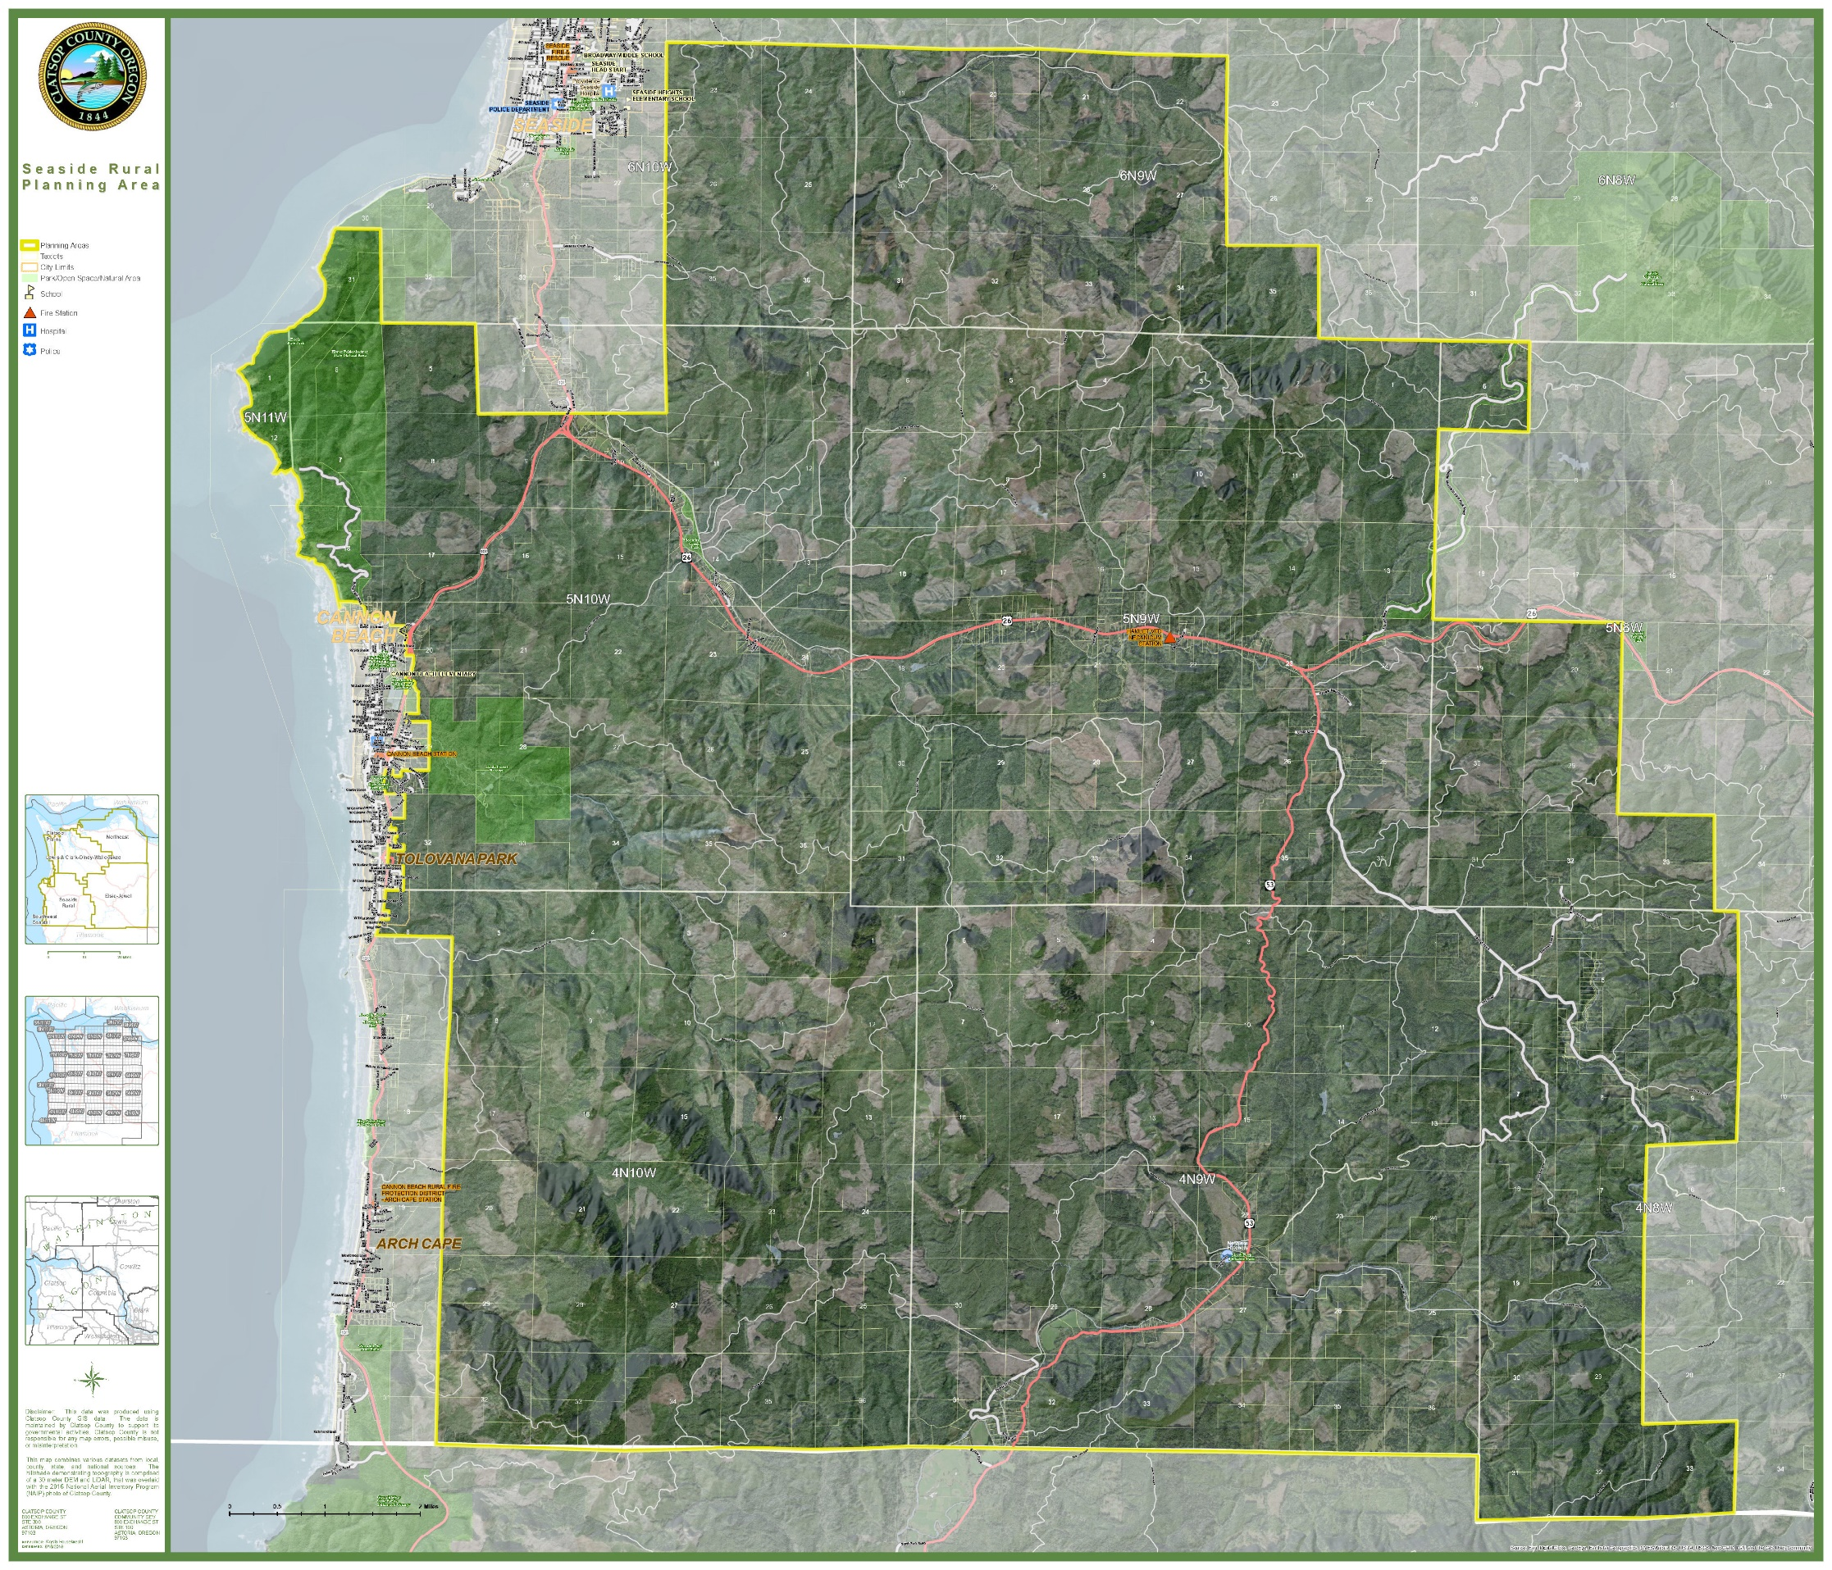
MAP 4: OPEN SPACE, PARKS AND RECREATION

The corridor encompasses an entire watershed, and includes the near-shore ocean, headlands, forested watershed, floodplain , and estuary. The corridor also creates a wildlife corridor.
Historic and Scenic Areas
Historical sites which have been inventoried in the Seaside Rural area include the Tillamook Head Trail, Tillamook Rock (lighthouse), Clark's View (on Tillamook Trail), Indian Beach (Ecola State Park), WWII Memorial (Highway 53 Junction) and an old cemetery on Hill Road in the Hamlet area. These sites are located on Map 4.
The Tillamook Head Trail leads south from Seaside over Tillamook Head through Ecola Park and into Cannon Beach. Clark's View, at 1,138 feet above sea level, was visited by Captain William Clark while on a trip to Cannon Beach. A monument marks the spot. Indian Beach is on the site on an early Indian fishing camp. These three sites are currently publicly owned and protected.
A lighthouse exists on Tillamook Rock that has been in existence since 1879. Official use of the light, however, was discontinued in 1957. The rock is now privately owned. Although there have been many speculative ideas to convert the lighthouse to such things as a gambling casino, access to the property is difficult and extremely dangerous. The structure itself is in a deteriorating condition and receives constant punishment by crashing breakers.
The World War II Memorial naming the Sunset Highway, once the Wolf Creek Highway, is located at the junction of Highway 53 and Highway 26.
Hamlet was named by early pioneers for its size. A post office was established there in 1905. The old cemetery has been donated to the community for preservation. Adjacent lands are in forest production.
The Hamlet School is owned and maintained by the Hamlet Historical Schoolhouse, a non-profit charitable organization.
Clatsop Chinook or other archeological sites exist in the Seaside Rural area. As development occurs, there will be inadvertent discoveries of areas, particularly around bodies of water, where the Clatsop Chinook utilized sites for temporary fish or food-gathering camps. Information regarding inadvertent discoveries of human remains, village sites and encampments should be reported to the Chinook Indian Nation and the State Historic Preservation Office.
Scenic areas in the Seaside Rural area include the rivers and highways. The highway from Silver Point to the Cannon Beach junction is a designated U.S. 101 Scenic Corridor, including a 50-foot buffer on both sides. Access is limited, no highway frontage is allowed, and all uses must be setback in accordance with Oregon Department of Transportation regulations.
Billboards and signs can also degrade scenic qualities. These are controlled by the Oregon Department of Transportation and local policies regarding highway commercial developments and the prohibition of off-premise signs.
Natural Areas
Possible natural areas of the Seaside Rural area have been identified through the Oregon Natural Heritage Program. They are described in Site Evaluation Reports and are summarized as follows. Also see Clatsop County's Goal 5: Open Space, Scenic and Historic Areas and Natural Resources in the Countywide comprehensive plan for additional discussion and resolution of conflicts.
Chapman Point is the first headland to the north of Cannon Beach with Ecola State Park immediately north. This 100-acre area, which is now owned by the Oregon Parks and Recreation Department, includes a beautiful rugged headland which is very steep and rocky. This is a very pristine area. The owner apparently discourages trespassers and is striving to maintain the natural character of the property. The fragile system could not stand excessive human use.
Onion Peak is located approximately 9 miles southeast of Cannon Beach. This is a steep-sided, rock peak, the highest in the area, at whose summit is a small remnant of the original Pacific Silver Fir-Western Hemlock forest. There is also a grassy bald area and a rock garden community, both showing minimal disturbances. Found here are a significant number of rare and localized plant species. Onion Peak is included among the eight sites in Oregon listed as a Dedicated Natural Heritage Conservation Area. The Oregon Natural Area Preserves Advisory Committee to the State Land Board has recently proposed the summit under State ownership for a "natural area preserve." (See Preserve Analysis: Onion Peak, September 1979). The Nature Conservancy is also negotiating with Crown Zellerbach to acquire their portion of the summit.
Sugarloaf Mountain is 2 miles south and 5 miles east of Cannon Beach. The summit of the mountain is approximately 10 acres with a rock garden community of rare plant species. In 2021, approval was granted to construct a new communication tower in this was area.
Grassy Lake is a two acre lake which is rapidly filling in an approaching a bog stage. This area presents a good example of aquatic succession uncommon at this elevation and is included here for its scientific significance.
Klootchie Creek Park, which includes amenities such as restrooms, trails, and a picnic area, also contains the remnants of the largest Sitka Spruce tree.

Fish and Wildlife
The sparsely populated areas of the County provide excellent habitat for many forms of wildlife, mammals and birds, reptiles and amphibians. Some of the more common forms of wildlife found in the Seaside Rural area include:
TABLE 2: FISH AND WILDLIFE
MAMMALS | BIRDS |  | GAME FISH
Roosevelt Elk | Pheasant | Sparrows | Steelhead Trout
Black-tailed Deer | Grouse | Solitary Vireo | Silver Salmon
Black Bear | Quail | Blackbirds | Chinook Salmon
Coyote | Mourning Dove | Widgeons | Chum Salmon
Wildcat | Pigeon | Shovelers | Cutthroat Trout
Muskrat | Grebe | Teal | Brown Trout
Mink | Phalarope | Owls | Rainbow Trout
Rabbit | Sandpipers | Peregrine Falcon
Raccoon | Seagulls | Hawks
Weasel | Cormorant | Marbled Murrelet
Ground Squirrel | Murre | Jays
Chipmunk | Killdeer | Oregon Junco
Beaver | Tufted Puffin | Rufous-sided Towhee
Mole | Thrushes | Starlings
Shrew | Ducks | Finches
Meadow Mouse | Merganser | Hummingbirds
Mountain Beaver | Geese | Trails
Red Squirrel | Crows | Cowbirds
 | Ravens | Golden Plated Warbler
 | Water Ouzels | Goldfinch
 | Golden Crowned Kinglets | Wren Tit, Bush Tit
 | Woodpecker

With reference to big game, the Oregon Department of Fish and Wildlife classifies areas within the County as Major Big Game Range, Peripheral Big Game Range and Excluded Range. For a discussion on Big Game and other fish and wildlife resources see Goal 5: Open Space, Scenic and Historic Areas, and Natural Resources Element.
The existence and management of vegetation is closely tied to the presence of wildlife. As large portions of the area's forest lands are logged, natural grazing habitat is created.
Abundant wildlife, primarily anadromous fish and crustaceans populate the streams of the area. The Necanicum and Nehalem Rivers and Elk Creek are the prime streams for anadromous fish runs. Anadromous fish hatch in upland freshwater streams, migrate to sea to spend a major part of their life, and return to the freshwater upland stream to spawn a new generation of fish. Important to these streams is the maintenance of water quality and low turbidity levels. A fish hatchery to augment the natural production of anadromous fish is located on the North Fork of the Nehalem. Soapstone Lake is stocked with cutthroat and rainbow trout. The streams and lakes of the area also provide water, as well as habitat, to many other species. The streambanks in the area are generally lined with red alder trees, which fulfill a dual function of shading the stream and keeping the water cool for fish, and holding the bank soils in place as a deterrent to erosion.
Since 1970, the Forest Practices Act has set standards and limitations on logging practices to ensure that activities have no detrimental effect on the water quality of the streams. Since most of the area's streams are in forest use, the Forest Practices Act will be enforced. Flood ordinances will also insure that no structures block stream channels.
Headwater areas are sensitive drainages that fish generally do not inhabit, but where human activities can cause a direct impact on downstream water quality. The goal for these areas is to reduce erosion and turbidity. Headwater areas in the Seaside Rural area are located in areas planned for forest uses which thereby limits development. Strict adherence to the Forest Practices Act will help to maintain water quality in headwater areas.
Transportation
The transportation system in the Seaside Rural area as well as the whole County, has been greatly influenced by the natural features of the land and water.
The major highway running north and south in the planning area is U.S. Highway 101 from the Cannon Beach junction to the City of Cannon Beach. No major improvements are currently planned. The City of Cannon Beach has three highway access points into the City, which has increased efficiency and safety for drivers.
Highway 26 (Sunset Highway) is the major State highway in the area which runs east-west. This road provides a connection between the resort communities on the coast of Clatsop County and Portland. There is some concern that in the future the highway will expand to a 4 lane system with very rigid controls on access. Access is not a problem at present but could pose problems at various curve sections of the highway.
The other principal road is State Route 53, a narrow two-lane mountainous highway which runs from Necanicum Junction, 13 miles east of Seaside on the Sunset Highway, south into Tillamook County. Some large dips and dangerous curves make this route unsuitable for intensive use. There are no railroad, water or air transportation facilities in this section of the County. There is also no transit bus service provided in the area. The area is not expected to build up to the extent that public transportation will be needed. The automobile, therefore, is the major transportation mode.
Most residents shop in Seaside and work close by. They Residents in the Seaside Rural Planning Area have learned to plan and limit trips to town by coordinating work activities with shopping needs. The distance to and from shopping, employment and residence is not a major problem, although a small neighborhood store in the area would probably be convenient.
Bicycling in the area is primarily recreational in nature. The terrain and nature of the highway system makes bike travel difficult and hazardous. There are no designated bikeways and none are planned, although U.S. 101 is a part of the Oregon Coast Bike Route and the TransAmerica Trail. A bikeway may be appropriate, however, from the Cannon Beach junction south to Cannon Beach along the "Old Highway" 101. Creation of an off-road bike path to bypass the Highway 101/Highway 26 junction is included in the County’s Transportation System Plan, adopted in 2015.
Because the Seaside Rural area is expected to be developed at very low densities, public transportation is not needed at this time to serve residents.
Some of the statistics concerning public facilities are updated in the Goal 11 element of the Comprehensive Plan.
Water Districts
There are no water districts in the Seaside Rural planning area.
The City of Seaside provides water to Stanley Acres and the area to the south of Seaside. The main water supply is from a source on the south fork of the Necanicum River about eight miles southeast of the city. An auxiliary supply source is located on the Necanicum River below the reservoir. The water treatment plant can produce approximately 2,800 gallons of drinking water per minute, or 4.032 million gallons of water per day. On a buy peak summer weekend, the amount of water usage is approximately 2.5 million gallons per day. In January 2021, the City completed construction of a 5-million gallon reservoir and pump station in Seaside’s East Hills. The reservoir will provide water to the new middle and high school buildings and to Pacific Ridge Elementary. The new pump facility will replace decommissioned pump stations in Sunset Hills and Whispering Pines.
The City of Seaside has been providing wastewater treatment to the community since 1939. The existing treatment plant began operation in 1986 and was upgrading in 2001 by the addition of a high-intently, ultraviolet light disinfection system to replace the City’s chlorine gas canister system. The plant provides secondary treatment of the City’s wastewater with a design capacity of 2.25 million gallons per day (MGD) with a maximum capacity of 6.75 MGD. Currently, the City is average a flow of 1 million gallons per day. The City utilizes bio-solids for land application on a city-owned farm and on leased pasture lands. The City of Seaside utilizes a series of collection basins, which drainage to a central collection point. A total of 25 pump stations are then used to convey the wastewater through force mains to the plants. The system consists of 30 miles of gravity sewer main, nine miles of force main, and over 600 manholes. In January 2021, improvements to the system were completed, which included a 5-million gallon reservoir and pump station in Seaside’s East Hills. This project was constructed in conjunction with the relocation of the middle and high school facilities.
In the event that availability of water is limited, the City utilizes the following service order of priority:
- Properties within the City limits
- Properties within the Urban Growth Boundary
- Other properties
An 18-inch City of Seaside water line extends from their headworks on the South Fork of the Necanicum through a portion of the Seaside Rural planning area. The water line intersects Highway 26 west of the Black Bridge and runs west on Highway 26 to Seaside. The City's present policy, however, is not to permit hook-ups to this line in areas outside the City limits. The City services hook-ups that were existing before they adopted this policy and also hook-ups to properties who granted an easement for City water lines in exchange for a hook-up right.
The water line does provide an abundant source of water for good fire protection for this section of the Seaside Rural planning area.
Also see the Public Facilities and Services Background Report and County-wide Element for additional information and policies.
Groundwater/Wells
Most of the Seaside rural area is underlain by fine-grained marine sedimentary rocks and volcanic rocks of low porosity and permeability. Water yields are low, except in the alluvial plains (along rivers). Rain falling on the impermeable slopes of volcanic and marine sedimentary rock is rejected and runoff is rapid. Amount of water that enters the rock units is small, although it will often yield an adequate amount for domestic use. Groundwater in the alluvial plains is more abundant due to the permeability of the gravels and sands and seepage from the river. Generally, water can be obtained at shallow depths in the wider floodplain areas.
Most wells in the alluvial lowlands produce good quality water for domestic use. Hard water, usually high in calcium and magnesium is likely to occur in wells in marine sedimentary and volcanic rocks.
Schools
The Seaside Rural planning area lies primarily within the Seaside School District #10. Portions of the northeast quadrant of the planning area are within Astoria School District #1 and portions of the southeast quadrant are within Jewell School District #8. In 2018, voters approved a bond initiative to allow the Seaside Middle and High Schools, as well as District administrative offices to be relocated outside of the tsunami inundation zone. Those facilities were completed in 2020 and the previously-used school facilities have or will be sold.
The Jewell School District prepared a facilities improvement plan in 2017. That plan includes additional housing for faculty and expansion of the gymnasium facilities.
TABLE 3: SEASIDE RURAL PLANNING AREA – SCHOOL SYSTEMS
System | Seaside School District #10 |  |  |  | Jewell School District #8
 | Pacific Ridge Elementary | Seaside Middle School | Seaside High School | Cannon Beach Academy Charter School | Jewell School
Grades | K-5 | 6-8 | 9-12 | K-5 | K-12
Enrollment | 654 | 374 | 427 | 45 | 114
Capacity
Year Built | 2003 | 2020 | 2020
Source: Oregon Department of Education
Presently all the children in the planning area are bussed to Seaside Schools except for an area on Highway 53 from the State Hatchery south to the County line. Children in this area attend school in Nehalem on a tuition basis. However, because of the costs of tuition, these children may in the future be bussed to Seaside Schools.
Fire Protection

There are 3 Rural Fire Protection Districts in the Seaside Rural planning area.
Seaside Rural Fire Protection District
Seaside Fire and Rescue was established in 1904. It is an all hazards department that responds to:
- Emergency medical calls
- Structure and wildland fires
- Water rescue
The Seaside Rural Fire Protection District contracts with the City of Seaside to provide fire protection for its district which extends north to Avenue E in Gearhart and 7 miles south of Seaside along Highway 26. The City of Seaside’s paid fire staff include the Fire Chief, Division Chief of Prevention, Division Chief of Operations, and two firefighter positions. The department also provides mutual aid to the Hamlet, Cannon Beach, and Gearhart rural fire protection districts. Per the 2020 Seaside Fire & Rescue Annual Report, there are 14 volunteer firefighters.
Currently available to the rural fire district are facilities of the Seaside Fire Department which consists of the following:
  - Volunteers - 41 men
  - 2 - 1500 gallon/minute pumpers
  - 1 - 1250 gallon/minute pumper
  - 1 - 3300 gallon tanker
  - 1 - salvage vehicle - carries all equipment necessary for the protection and salvage of a structure (shovels, tarp, pumps to extract water, etc.)
  - 1 - rescue vehicle
  - 2 - jeeps for fire prevention
  - 2 - service trucks
The Oregon Insurance Bureau has developed a protection class scale from 1 to 10 to aid in fixing insurance premiums for homeowners. The lower the rating, the lower the premium.
The district has an insurance rating of 4 in the Seaside Rural area -one of the first, if not the first, all-volunteer fire departments in the state to receive the Class 4 rating. Most of the other rural County insurance ratings are between 8 to 9.
One of the reasons the district received the Class 4 rating was the good supply of water from the Seaside water line running along Highway 26. Fire hydrants are located at the Crab Broiler, mobile home park on Highway 26, Klootchie Creek and Edgewater Terrace.
The other major reason for the low rating is the automatic aid system with the Gearhart and Cannon Beach fire departments.
Cannon Beach Rural Fire Protection
The Cannon Beach Rural Fire Protection District extends from the north Cannon Beach city limits to the Arch Cape tunnel. The Cannon Beach Rural Fire Protection District was formed in 1947 to protect the citizens of the Cannon Beach area from the threat of fire. As the area grew, so did the need for more space and equipment. A second station was built in Arch Cape and in 1996, the original station (located downtown) was replaced with the current station at 188 East Sunset. The original mission of the volunteers was to extinguish fires; however, it soon became apparent that there were other demands for service. In the 1950’s search and rescue was formed, and in the 1970’s Emergency Medical Services. Soon after high angle rescue and surf rescue joined the list of provided services.
Today Cannon Beach Fire District personnel provide firefighting and EMS services to the Northwest Oregon coastal communities of Cannon Beach, Arch Cape, and Falcon Cove and a tourist population of 750,000 to 1,000,000 annual visitors. As of 2020, paid professional staff included a Fire Chief, Recruitment & Retention Coordinator/Lieutenant, and one part-time administrative staff. Volunteers include two volunteer lieutenants and 11 volunteer firefighters. The district, as of 2018, had an Insurance Service Office (ISO) rating of 3.
The following equipment and men are presently available:
Volunteers - 32 men
3 - 750 gallon/minute pumpers
1 - 1500 gallon/minute with a storage capacity of 1000 gallons
1 - Off-road vehicle mini-pumper
Fully equipped aid car
Aerial ladder truck
The district's insurance rating within the city limits of Cannon Beach is 6. For the rural area the rating is 8 to 9.
The major reason for the high fire insurance rating in the rural areas is a lack of adequate water supply or, in areas where there is community water, the water lines are too small to enable pumping of water for fire purposes.
Hamlet Rural Fire Protection District
The Hamlet Rural Fire Protection District covers portions of Highway 26 and 53 and the Hamlet area. The district levies a tax of 1.2429 and has an Insurance Service Office (ISO) classification of 4 no taxes. Per information from USFireDept.com, Hamlet RFPD operates two stations utilizing an all-volunteer force. The District provides the following services, in addition to offering mutual aid to Seaside Fire and Rescue and Elsie Vinemaple RFPD:
- Advanced life support
- Basic life support
- Emergency medical responder
- Haz-mat operational level
- Rescue operational level
- Structural fire suppression
- Wildland fire suppression
The District has a high call volume of motor vehicle accidents on Highway 26 and performs rescues on hiking trails and logging roads utilizing drones and GPS coordinate training.
The district presently has the following equipment and men:
Volunteers - 15 men
1 - 750 gallon/minute pumper
Army tanker with capacity of 1,100 gallons
The district has an insurance rating of 9 to 10. The 911 emergency telephone number is operational in the district, as in all the County fire districts.
Septic Systems
The Seaside Rural residents are served by septic systems. Because of soil limitations, lot size, and slopes, each proposed subsurface sewage disposal site is considered on an individual basis.
A critical consideration in septic tank operation is development density. Problems result when development densities become too great for the soil to accommodate the resulting effluent discharges which could eventually surface and/or contaminate wells and other groundwater sources. The result is a potentially dangerous health situation.
Power Generation
Currently, all electrical power in Clatsop County is supplied by the Bonneville Power Administration (BPA) and is distributed, mainly, through the Pacific Power and Light Company (PP&L). Small amounts of electricity are sold to and distributed in the Seaside Rural area by the Tillamook Public Utility District. The primary PP&L transmission lines serving the County are 115 KV lines from the Longview substations in Astoria, Cannon beach, Fern Hill, Knappa Svensen, Lewis and Clark, Seaside, Warrenton, and Youngs Bay (Source: 2021 Oregon Distribution System Plan, PacifiCorp).
The Tillamook Public Utility District has a 24.9 KV line extending into Clatsop County which presently serves about 30 families homes on Highway 53 from the State Fish Hatchery south to the County line.
There are no natural gas lines serving this area of the County.

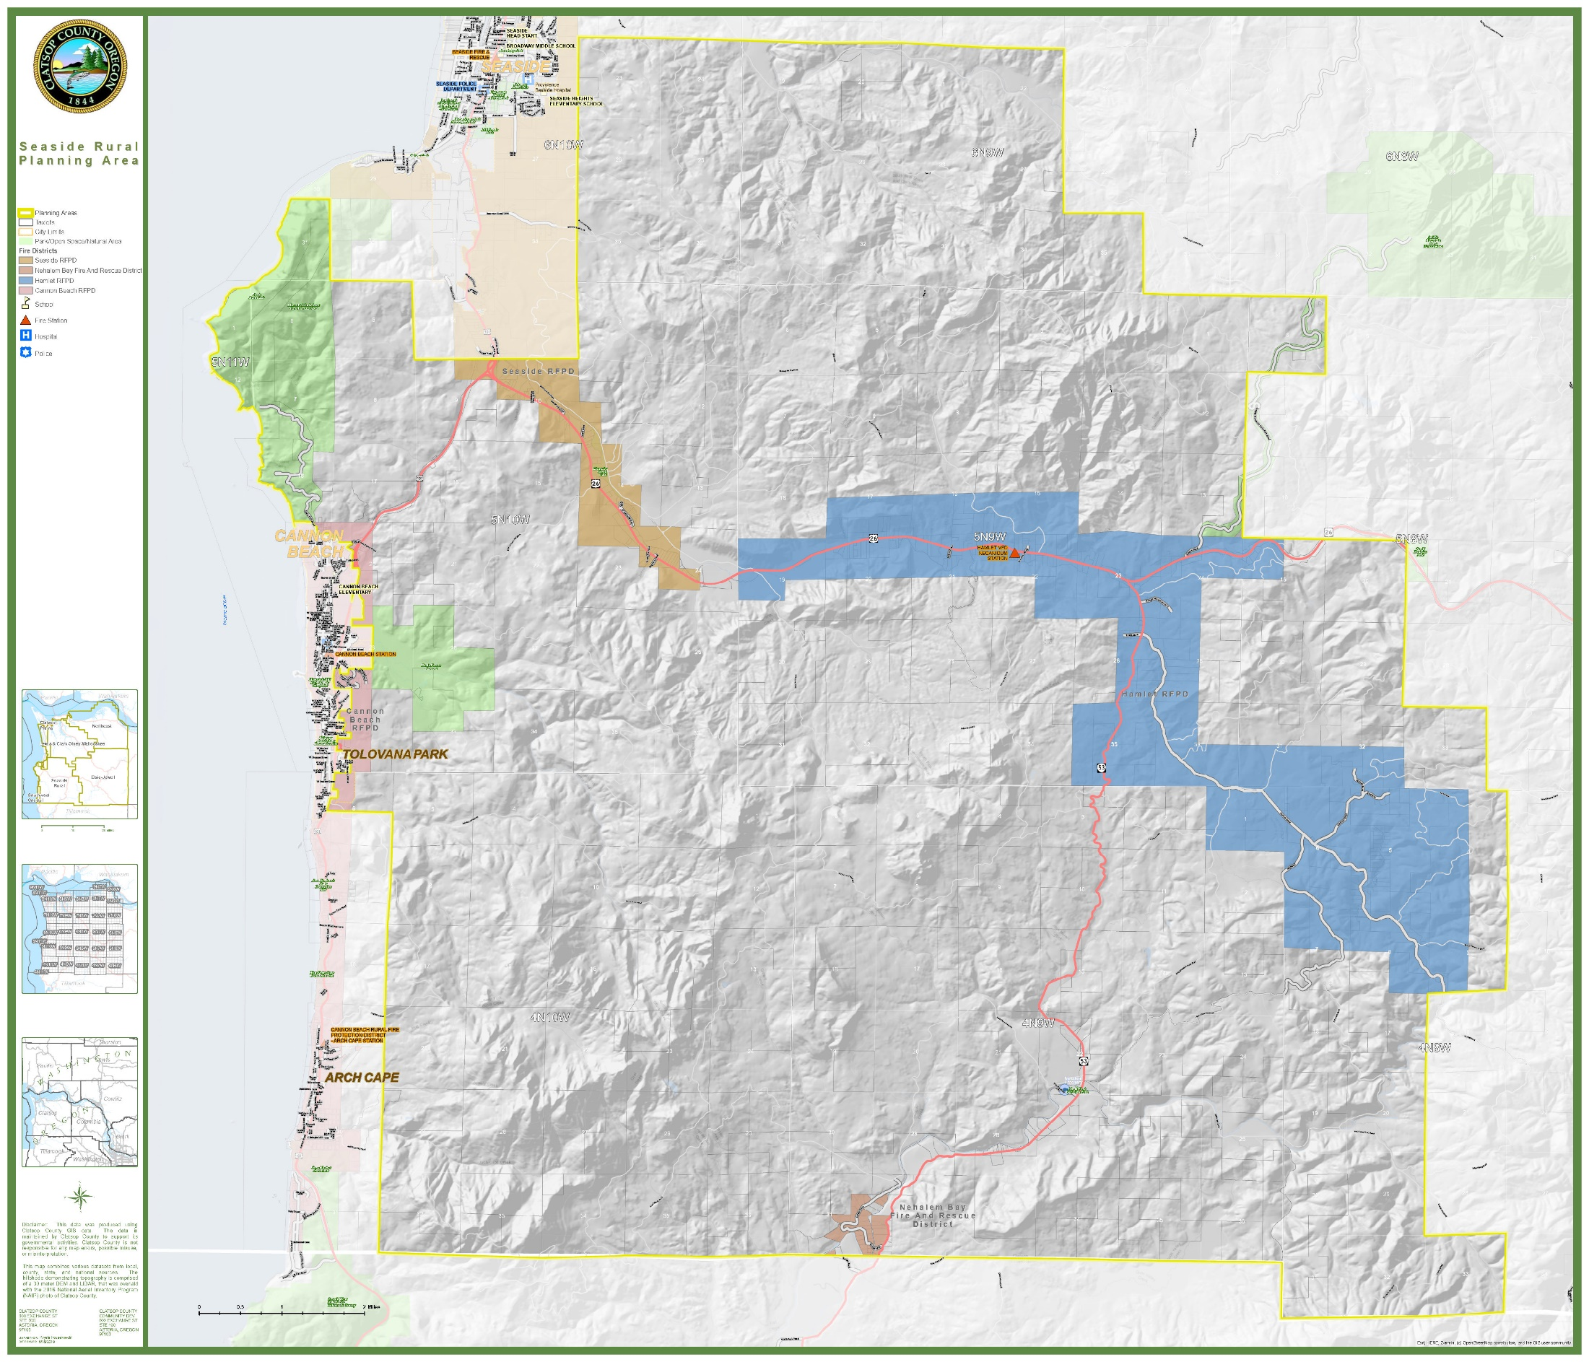
MAP 5: SPECIAL DISTRICTS

COMMUNITY DEVELOPMENT
Setting
The Seaside Rural planning area is an area of dramatic beauty. As one travels south from Seaside on U.S. Highway 101, the bold promontory of Tillamook Head looms as the first landmark of the planning area. The head offers outstanding vistas and stands of old growth sitka spruce forest in Ecola State Park on top of a massive rock formation.
Continuing on, the highway begins to drop into the area of Cannon Beach and Tolovana Park, between the Pacific Ocean and the relatively low but rugged peaks of the Coast Range. Sugarloaf Mountain (2,853 feet) is the most prominent peak to the east with the distinctive Double Peaks ahead, closer to the ocean. Haystack Rock and the Needles can be seen to the west.
The eastern section of the planning area contains the lush and productive river valleys of the Necanicum and Nehalem Rivers, a vast area of forested peaks and canyons including Saddle Mountain, clear-cuts, and dark basalt rock outcrops.
Highway 26 provides the main route of transportation east and west, with Highway 53 for north-south travel to the County boundary. These routes basically follow the two rivers.
Homesites are scattered along the highways, with some tourist commercial development occurring at the major junctions. Most of the individual property owners own between 1-9 acres of land and have resided in the area from 1-15 years.
Assumptions
One of the things that makes the Seaside Rural area a pleasant place to live in the low density character of housing that has traditionally occurred. The area is peaceful and private and has grown very slowly in the past. This is due partly because of the vast amount of commercial timberland that dominates the area in contrast to the very small individual property ownerships.
The Plan is based upon the best information available, desires for future livability, economic and environmental balances, and lastly to comply with the Statewide Planning Goals and Guidelines.
Growth is to be managed to minimize or avoid environmental, cultural or economic conflicts.
Below are the definitions, objectives and policies for DEVELOPMENT, RURAL LANDS, RURAL AGRICULTURAL LANDS, FOREST LANDS, and CONSERVATION OTHER RESOURCES.
Development
DEVELOPMENT areas are those with a combination of physical, biological, and social/economic characteristics which make them necessary and suitable for residential, commercial, or industrial development and includes those which can be adequately served by existing or planned urban services and facilities.
Lands within an Urban Growth Boundary are those determined to be necessary and suitable for future urban growth, and are included in this designation. The Urban Growth Boundary for the Seaside Rural area is around Cannon Beach.
The approximately 200 1,100 acres of buildable, vacant land included both within and outside the city limits, and within the Urban Growth Boundary represents the growth needs of the City for the next 20 years. Lands within the boundary are presently served by sewer and/or water, or are capable of being serviced in that they are generally below 140 feet of elevation. No commercial forest lands are included in the boundary.
The Elk Creek estuary, outside the city limits, is excluded from the Urban Growth Boundary. Lands with steep slopes, known or suspected geologic hazards, and which are considerable distances from city services are excluded from the boundary.
Policies pertaining to the Cannon Beach Urban Growth Boundary are contained within the Countywide Urbanization Element (Goal 14).
Rural Lands
RURAL LANDS are those lands which are outside the urban growth boundary and are not agricultural lands or forest lands. Rural lands include lands suitable for sparse settlement, small farms or acreage homesites with no or hardly any public services, and which are not suitable, necessary or intended for urban use.
Rural Lands are those which, due to their value for aquaculture, low density residential uses, high intensity recreational uses, and non-renewable mineral and non-mineral resource uses should be protected from conversion to more intensive uses. Rural subdivisions, major and minor partitions, and other uses served by few public services which satisfy a need that cannot be accommodated in urbanizable areas are also likely to occur within this designation.
Most Rural Lands designation in this Plan area contain old town plats and fragmented land ownerships. These areas may require vacation and replatting or utilization of a Planned Development to protect the natural resources of the area.
Rural Agricultural Lands
Agricultural lands are those lands that are to be preserved and maintained for farm use, consistent with existing and future needs for agricultural products, forest and open space.
In land use changes involving a change from Forest Lands or Rural Agricultural Lands to Rural Lands or Development designations an Exception to the Agricultural Lands or Forest Lands Goals must be taken.
Predominant Uses in the Rural Agricultural Lands Classification include:
1. Farming (see Goal 3: Agricultural Lands).
2. Small woodlots.
3. Low density residential (2 acres or more).
4. Commercial (gas station, grocery store).
In the Seaside Rural area there are about four distinct areas of housing. Because of the unique circumstances which characterize these areas, different lot sizes have been designated.
In order to compliment Cannon Beach's Plan and to buffer the urban area from adjacent forest land, a fivetwo-acre zone has been designated for land outside of the Cannon Beach Urban Growth Boundary. The Seal Rock and Elkwood Mountain subdivisions, however, have been zoned for an average lot size of two acres because of ownership patterns existing at the time the original comprehensive plan was adopted in 1980.
The residential area from the Cannon Beach junction to Black Bridge is within the Seaside fire district and close to the commercial centers of Seaside and Cannon Beach. Because of the built-up nature of the area, this area has been zoned for two-acre parcels.
The area east of Black Bridge to the Highway 53 junction has been zoned for five-acre parcels because of the distance to commercial areas and the existing average lot size in 1980 when the comprehensive plan was originally adopted.
The area near the southern border of the County and close to Nehalem has been zoned for five-acre parcels. Many small ownerships occur in the area.
Forest Lands and Conservation Other Resources
Forest Lands
Forest lands are those lands that are to be retained for the production of wood fiber and other forest uses.
In land use changes involving a change from Forest Lands or Rural Agricultural Lands to Rural Lands or Development designations an Exception to the Agricultural Lands or Forest Lands Goals must be taken.
Conservation Other Resources
Conservation Other Resources areas provide important resource or ecosystem support functions such as lakes and wetlands and federal, state and local parks. Other areas designated CONSERVATION OTHER RESOURCES include lands for low intensity uses which do not disrupt the resource and recreational value of the land. Preservation of both large and small wetlands is important. Even small or isolated wetlands can retain water during dry summers and are integral to hydrological systems within the planning area.
Predominant Uses in the Forest Lands and Conservation Other Resources Classifications include:
1. Forestry/forest processing. (see Goal 4: Forest Lands).
2. Farming.
3. Parks and scenic areas.
4. Small woodlots.
5. Community watersheds.
Natural
A NATURAL area is defined as land and/or water units in which natural processes exist relatively undisturbed or can be restored to a nearly natural state. Natural areas include:
1. Native terrestrial, freshwater or marine ecosystems, e.g. a salt marsh or stand or old growth forest.
2. Areas containing significant biological, geologic, hydrologic, paleontological, archeologic or scenic features, e.g. a single fossil bed or waterfall.
3. Areas particularly valuable for plants and wildlife:
a. as habitat for rare, endangered, endemic or otherwise unique species;
b. as exceptionally productive or diverse habitat;
c. as vanishing habitat;
d. as habitat crucial to a stage in a species' life style, e.g. spawning grounds, or wetlands along flyways.
Natural areas are important to the community as a whole, for they offer a unique aesthetic and educational experience; i.e., the opportunity to view, study and explore the array of natural elements witnessed by the early explorers of our region. They serve as the natural heritage to be passed on to future generations.

GOALS, OBJECTIVES AND POLICIES
SEASIDE RURAL PLANNING AREA OVERALL GOAL
To preserve and maintain the present overall rural quality of life now enjoyed in the Seaside Rural area.

ALLUVIAL LOWLANDS POLICIES
Policy 1: Low intensity activities, such as low density housing and agriculture, shall be preferred uses in the alluvial lowlands.
Policy 2: Residential development shall be at low densities (generally 2-5 acres) because of the occurrence of high groundwater and seasonal stream flooding.

SEDIMENTARY UPLANDS POLICIES
Policy 1: Generally, the sedimentary lowlands and uplands should be reserved for timber production, water supply protection, and wildlife habitat.
Policy 2: Any construction in these areas should recognize the potential detrimental effect it may have on the land in terms of runoff, erosion, drainage, or reduced stability.

BASALTIC LOWLANDS AND HIGHLANDS POLICIES
Policy 1: The highlands should be designated as a resource. Uses other than woodland, wildlife habitat, low intensity recreation, natural and mineral resources shall be controlled by the County to avoid conflicts.
Policy 2: Residential development on basaltic lowlands and highlands (located in the Hamlet area) should be confined to the area along existing roads which are not characterized by steep slopes.
Policy 3: Small woodland management shall be encouraged.

TILLAMOOK HEAD POLICIES
Policy 1: Tillamook Head shall be preserved as a unique coastal land formation. Uses other than forest management, wildlife habitat, low-intensity recreation, natural and mineral resources shall be discouraged. New mining operations on Tillamook Head which are in view of Highway 101 shall be screened with an appropriate buffer of trees.
Policy 2: The County should continue to monitor water management and conservation plans of surrounding jurisdictions and special district for consistency with the county comprehensive plan.

NATURAL HAZARDS POLICY – GENERAL
Policy 1: The County shall promote education to ensure that households are prepared to be self-sufficient for a minimum of two weeks as natural disasters can leave residents in the Seaside Rural Planning Area isolated.

NATURAL HAZARDS POLICY – STREAMBANK EROSION
Policy 1: The County should develop hardening standards for new construction in wildfire risk areas. For example, require spark arresters, metal roofs, fire retardant siding, and vegetative clearing.

NATURAL HAZARDS POLICY – WILDFIRE
Policy 1: The County should discourage actions on or adjacent to the river banks to reduce or eliminate problems from natural erosion and to minimize impacts on adjacent land.

NATURAL RESOURCES POLICIES – WATER
Policy 1: The County should continue to monitor water management and conservation plans of surrounding jurisdictions and special districts for consistency with the county comprehensive plan.
Policy 2: Development or land uses located on land not regulated by the FPA that require channelization, excessive removal of streamside vegetation, alteration of stream banks, and filling into stream channels shall be restricted in order to maintain stream integrity.
Policy 3: Consideration shall be given to protection of the lakes from further degradation (eutrophication), and possible remedial actions to improve water quality.
Policy 4: The County should encourage water storage/holding tanks/catchment systems for new residential and commercial development within the planning area.
Policy 5: In order to ensure that the County is not requiring surplus capacity to serve development, the County should review its minimum water flow requirements to ensure that its requirements are consistent with actual usage patterns. Required water flow should be based on the number of fixtures and/or house size.
Policy 6: The County shall encourage new innovation and concepts to conserve and/or reduce water usage including, but not limited to grey water recycling, as permitted under OAR 340-053. Legalized in OR in 2012.

NATURAL RESOURCES POLICIES – TSUNAMI
Policy 1: An evacuation route should be located within the Seaside Rural Planning Area.

NATURAL RESOURCES POLICIES – EARTHQUAKES / CASCADIA SUBDUCTION ZONE EVENT
Policy 1: CERT volunteer training should be encouraged and cache areas and assembly points should be identified and developed.
Policy 2: The County shall promote education to ensure that residents and households are prepared to be self-sufficient for a minimum of two weeks in the event of a CSZ occurance.
HOUSING POLICIES
Policy 1: The location of a single mobile home (minimum width - 12 feet, minimum floor area, 600 square feet) on an individual parcel of land shall be allowed in all areas of the Seaside Rural area, subject to standards contained in the Zoning Ordinance.
Policy 2: The County should work to reduce barriers to permitting accessory dwelling units on rural residential lands to the greatest extent possible.
Policy 3: The County should explore the creation of new, or the use of existing RV parks, to provide semi-permanent places for persons who would otherwise be unsheltered or who occupy RVs on land without access to sanitary services and/or potable water.

RECREATION POLICIES
Policy 1: Non-intensive recreational uses of the shoreland and water areas that are compatible with the rural character of the area (fishing, bird watching, picnicking) shall be preferred over noisy high intensity uses.
Policy 2: Public access to the Necanicum River and North Fork of the Nehalem River currently exists at several locations shown on Map . If new data indicates a need in the future, new access shall be developed on public land with adequate provisions made for the protection of adjacent privately owned land. Riparian areas adjacent to new public access points shall be protected to the greatest extent possible.
Policy 3: Existing public land shall be preferred for recreational development, but shall not prohibit acquiring additional locations.
Policy 4: Subdivision or planned developments along major streams and rivers shall provide access points to the water for residents of the development. Provision of such access points shall not prohibit acquisition of additional locations.
Policy 5: The County shall pursue the development of a safer bike path along Old Highway 101 to Cannon Beach. The State should incorporate the bike path with Highway 101 improvements planned for the area. This bike route should be given high priority.
Policy 6: The County will work to identify and establish public access facilities along the main stem of the Nehalem River.

CULTURAL AREAS POLICY
Policy 1: The County should encourage public and private property owners to allow archaeological excavations within the lower Nehalem area in order to increase knowledge and awareness of the history of this area.
Policy 2: Information regarding inadvertent discoveries of human remains, cairns, village sites, artifacts and encampments should be reported to the Chinook Indian Nation and the State Historic Preservation Office.

HISTORIC AND SCENIC AREAS POLICY
Policy 1: Uses of Tillamook lighthouse shall enhance historic preservation, maintain the integrity of the coastal waters, require little or no public access and shall not substantially alter the external appearance of the site except to restore its historic appearance.
Policy 2: Within five years of the adoption of this plan, the County shall conduct ESEE analyses for the following sites to determine whether they should be included in the Goal 5 inventory of historic resources:
- Hamlet School
- Hamlet Cemetery

NATURAL AREA POLICIES
Policy 1: Fragile and ecologically valuable area, especially wetlands, isolated lakes, stands of old growth timber, and areas of rare or endangered species will be considered for a NATURAL designation.
Policy 2: The predominant use for NATURAL areas shall be open space, scientific study, wildlife habitat, and low intensity recreation (trails, nature observation).

FISH AND WILDLIFE POLICIES
Policy 1: Residential development in areas of big game habitat shall be of a low density so that potential conflicts (i.e. damage to gardens, yards, etc.) can be minimized.
Policy 2: Mining, dredging, or removal of gravel or similar materials from streams and other surface water shall be strictly controlled to prevent adverse alteration to flow characteristics, siltation and pollution, and destruction or disruption of spawning areas.
Policy 3: Motorized vehicles that are used for recreation should be restricted to existing established trials and roads.
Policy 4: Because of the importance of fish hatcheries, activities or developments that could be detrimental to the water quality are discouraged in these creeks and the waters which drain into them.
Policy 5: To conserve and protect fish and wildlife habitat, new developments shall be designed and constructed so as to:
- maintain wherever possible a natural, vegetative buffer strip along wetlands and streams;
- minimize the alteration of land and vegetation; and
- preserve open space, including agricultural and forest lands

TRANSPORTATION POLICIES
Policy 1: The County supports continued efforts by the Oregon Department of Transportation to improve safety and traffic flow at the junction of Highway 101 and Highway 26.
Policy 2: When the State Department of Transportation improves U.S. Highways 101, 103, 26, 53, and 202, consideration should also be given to provision of a safe bikeway, suitable crosswalks, fog lines and the installation of curbing to separate the auto traffic where possible.

POWER GENERATION POLICY
Policy 1: The use of alternative energy sources and also the development of private and community energy systems is encouraged.

COMMUNITY DEVELOPMENT POLICIES – RURAL LANDS CLASSIFICATION
Objective 1: To retain RURAL LANDS as sparse settlement, small farms or scattered acreage homesites with hardly any public services.
Policy 1: When considering new commercial buildings or when existing commercial uses are considering expansion, the following standards shall be required:
- Adequate off-street parking shall be provided.
- A buffer of landscape planting area shall be provided when abutting residential zones. Plants should be native to Wester Oregon.
- Highway approaches should be minimized whenever possible through the use of common driveways, access points, and other means such as clustering buildings and shared parking.
- Signs shall be designed so as not to distract from the surrounding area. Use of natural materials is encouraged. When lighting is necessary it shall be subdued and indirect.
Policy 2: New commercial zones shall only be considered if of a neighborhood type or if concentrated in and adjacent to existing, well-established business areas, in order to increase the patronage and vitality of these areas and to avoid undue dispersal of new commercial activities.

COMMUNITY DEVELOPMENT POLICIES – CONSERVATION OTHER RESOURCES CLASSIFICATION
Objective 1: To conserve and protect natural, scenic, historical and cultural resources.
Objective 2: To develop for low-intensity uses which do not substantially degrade the existing character or interrupt the flow of natural resource use or recreational benefits.
Objective 3: To protect life and property in hazardous areas.

COMMUNITY DEVELOPMENT POLICY – FOREST LANDS CLASSIFICATION
Policy 1: Designated forest lands should be managed for forest uses.
Policy 2: Forest Lands shall be designated Forest Lands in the County's Comprehensive Plan.

COMMUNITY DEVELOPMENT POLICY – NATURAL CLASSIFICATION
Policy 1: The summit of Onion Peak boundary (as described in the Preserve Analysis, September 1979 by the Natural Area Preserves Advisory Committee) and a small meadow on the summit of Sugarloaf Mountain support sub-alpine type "grass bald" and "rock garden" communities with eleven or more rare or endangered species. These areas shall be designated NATURAL, and preserved for research and education. An established hiking trail is not recommended as the areas are small and fragile and could not tolerate trampling and soil erosion.
Policy 2: The Elmer Feldenheimer forest preserve shall be designated NATURAL.

COORDINATING AGENCIES:
Oregon Department of Fish and Wildlife (ODFW)
Oregon Department of Agriculture (ODA)
Oregon Parks and Recreation Department (OPRD)
Oregon Department of Energy (ODOE)
State Historic Preservation Office (SHPO)
Oregon Department of State Lands (DSL)
Oregon Health Authority (OHA)
Department of Geology and Mineral Inventories (DOGAMI)
Oregon Department of Land Conservation and Development (DLCD)
Oregon State Historic Preservation Office (SHPO)
Clatsop Soil and Water Conservation District

BACKGROUND REPORTS AND SUPPORTING DATA:
2021 Oregon Distribution System Plan, PacifiCorp

