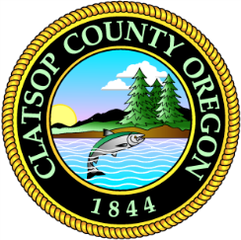
Building and Grounds

November 21st, 2023

To Whom It May Concern:

Through the Request for Quotes Process the County received one proposal:

- Apollo Plumbing Services - $93,670.75

Clatsop County
Matthew Gerber
Facility Manager
(503) 325-8565

