How to access a septic record from Clatsop County Webmaps

Begin with this link:
https://delta.co.clatsop.or.us/portal/apps/webappviewer/index.html?id=66f9167f01304850aacc7ad1a0d3d217

Click on icon: the Search Tools bar will open

Click on icon: 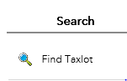

the “Find Taxlot” options will open and look like this below.
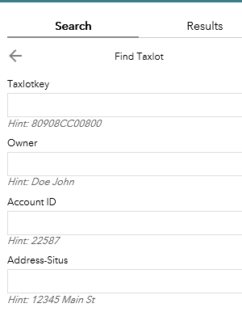

Use any of the 4 options to search and click on Apply at the bottom

The Results will appear in the tab next to Search

Click on the Account number:
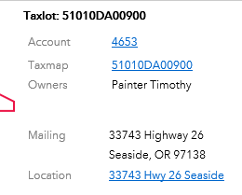

A new window will appear. Click on Documents tab shown below.

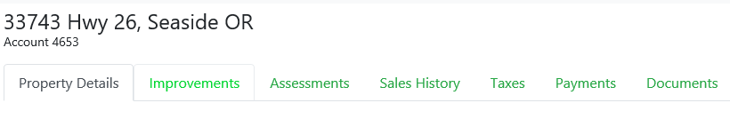

Septic Records will have its own tab
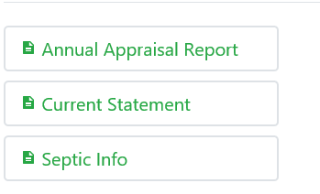

If you do not see the “Septic Info” tab for your specific property please contact the Clatsop County Environmental Health Office by email at EnvHealth@co.clatsop.or.us or by phone at 503-325-9302 to see if any records exist for the property.

